**Best Travel and Tours**

In this report, we will be looking at what each part of the Best Travel and Tours website does.

When you look at the first section of the website, this is where you come to learn about what the page is about as it offers you a general introduction. It also allows you to look for a certain place that you may fancy visiting.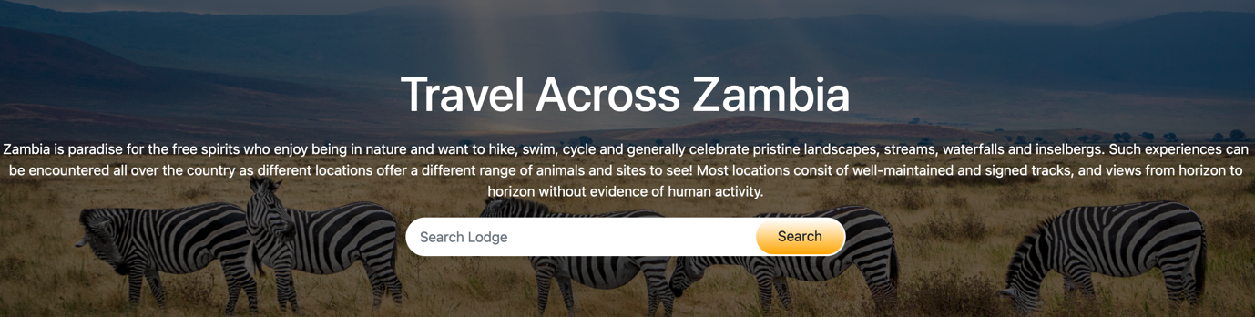

In the next section the user a sample of some of the places that Best Travel and Tours is associated with. This sample gives a description, the rating and the price of the place which gives the user a general idea of what they could expect if they chose to go and visit that place. This is a place where they would they decide on where to go depending on their budget.

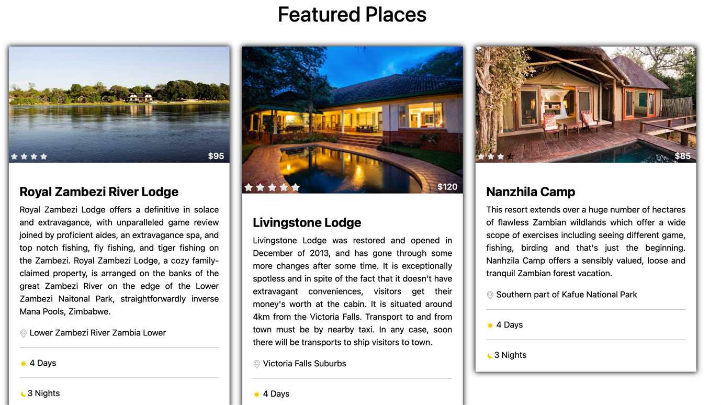

When you move onto the next section, it is a little different from the rest of the website in that the website allows the user to directly go to the website of their desired location and from there they would be able to have a look at the pictures on their desired location’s website.

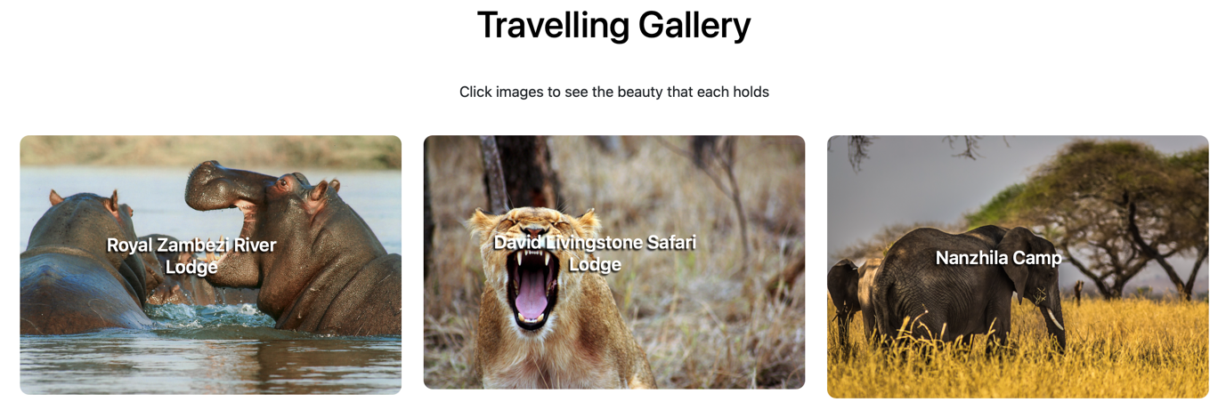

The next section of the website is where we as a company try and reel in as many customers as possible by showing them what promotion we have. It is proven that there are higher chances of having someone buy a product or service if there is a certain perk to, in this case a discount. By offering a discount to the different locations that Best Travel and Tours is connected to, they increase their chances of getting more business for themselves as well as raising awareness.

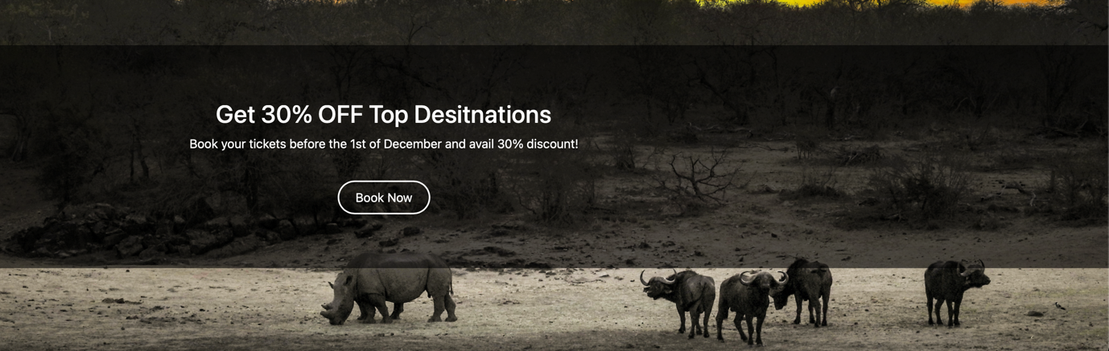

When we scroll over to the next part of the website, new customers are given the chance to have aa look at the feedback that other user leave behind as a way of coaxing the new customers into trying out the services offered by Best Travel and Tours.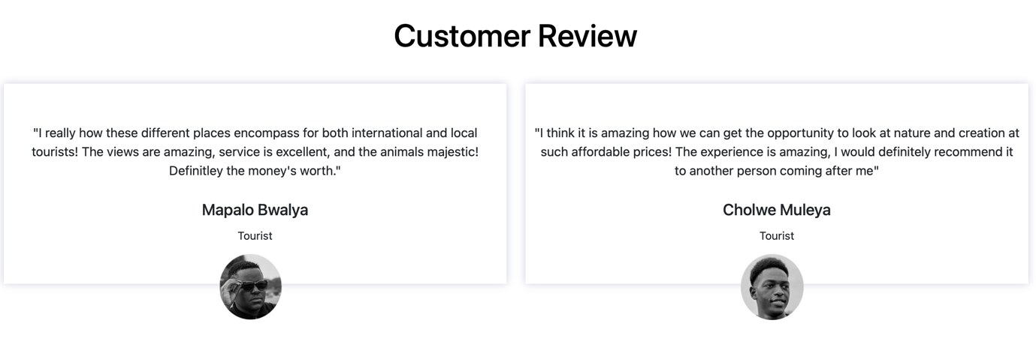

The final part of the website is the footer where the user can gather information of where else they would be able to find Best Travel and Tours as well as how else they can reach them. 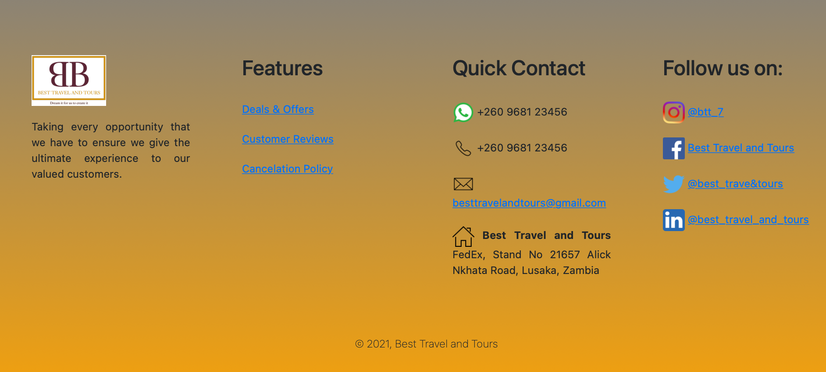

This website is conducive in that it is pretty straightforward and easy to follow, when the user needs something they can easily get there and not have to go through different complicated methods which. Having a simple, easy to use website is beneficial to both the business and the user in that it encourages the user to want to explore more, therefore, giving the business more customers.